**Village of Point Edward**

**2021 - 2024 Multi-Year Accessibility Plan**

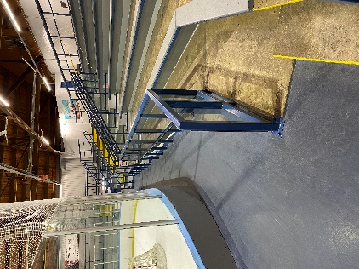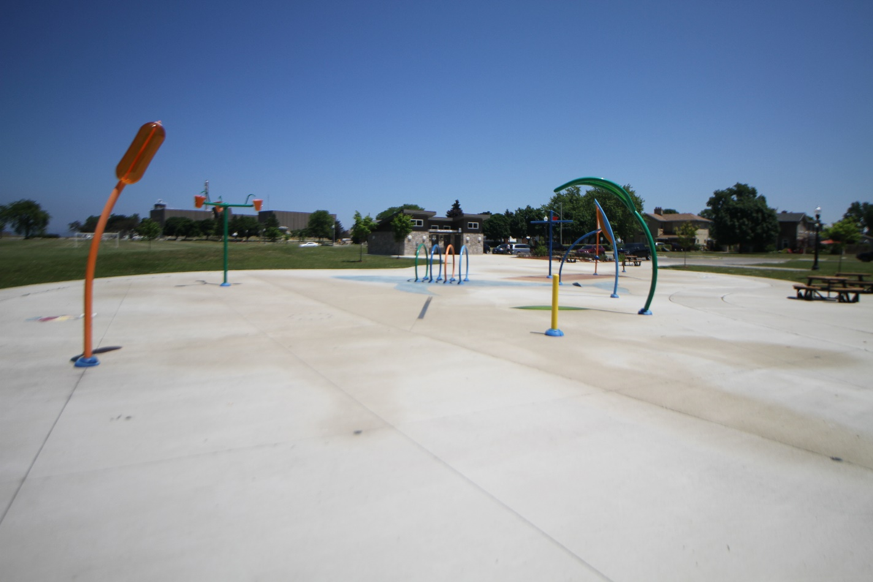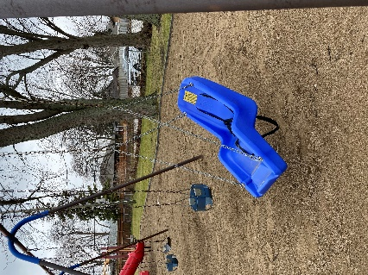

If you require this document in another format, please contact the Village of Point Edward at 519-337-3021

**Table of Contents**

Message from the Mayor 3

Message from the Chief Administrative Officer 3

Consultation Activities 3

Acknowledgement of Village Staff 4

Legislation 4

Accessibility Plan 6

General 6

Customer Service Standard Accomplishments 7

Information and Communication 8

Employment 9

Design of Public Spaces 9

Action Items Outside of the AODA Requirements 12

Maintenance 12

Review Process 13

Responsibilities 13

Appendix A 14

# Message from the Mayor

“The Village of Point Edward has made great progress in promoting a barrier-free community for residents, employees, and visitors. Through this plan, the Village will continue the on-going process of creating a caring and inclusive community for all to enjoy. The Village remains committed to enhancing programs, services, and public spaces to ensure they are accessible to all residents and visitors.”

Mayor Bev Hand

# Message from the Chief Administrative Officer

“The Village of Point Edward is committed to ongoing improvement to accessibility within the Village and achieving the requirements set by the Accessibility for Ontarians with Disabilities Act (AODA) and the goals within this plan.

This report outlines our accomplishments to date as well as priorities planned for the next 3 years. Special thanks are extended to staff for their efforts and commitment to successful implementation of AODA standards to date. By developing initiatives in the key areas outlined in this multi-year plan, we continue to remove and prevent barriers to create a more inclusive community for residents.”

Jim Burns, Chief Administrative Officer

# Consultation Activities

The Village of Point Edward is in the process of developing an Accessibility Advisory Committee that will advise both Point Edward Council and staff on matters pertaining to persons with disabilities in the community, as defined in the Ontario Disability Act (ODA) and the Accessibility for Ontarians with Disabilities Act (AODA).

The Accessibility Advisory Committee will assist in the identification, removal and prevention of barriers faced by persons with disabilities at Village of Point Edward facilities, public spaces and programming. The committee will be consulted on the following items:

* Accessibility Plans
* Development of bus stops *
* Accessible Design of Trails
* Accessible Design of Outdoor Play Spaces
* Accessible Design of Exterior Paths of Travel
* Need, Location; and Design of Accessible On-street Parking Spaces

* Please Note that the City of Sarnia delivers transit services on behalf of the Village of Point Edward and are responsible for all the requirements under the AODA Transportation Standard.

# Acknowledgement of Village Staff

A special thank you is extended to the staff members at the Village of Point Edward for all their hard work, time, and commitment to identifying and removing barriers and developing barrier-free programs, services and facilities.

# Legislation

**Bill C-81 Accessibility Canada Act**

The Government of Canada consulted with Canadians to find out what an accessible Canada means to them. On June 20, 2018, the Government introduced Bill C-81, An Act to ensure a barrier-free Canada (the Accessible Canada Act) in Parliament. The Accessible Canada Act received Royal Assent on June 21, 2019, and came into force on July 11, 2019. It is important to note that Bill-C-81’s purpose is to identify, remove and prevent accessibility barriers in areas that fall under **federal jurisdiction**.

**Ontario with Disabilities Act (ODA)**

The ODA was established and became law in 2001. The purpose of the Act is to achieve a barrier-free Ontario for people with disabilities. The Act called for all municipalities to assist in identifying, removing, and preventing of accessibility barriers.

**Accessibility for Ontarians with Disabilities Act (AODA)**

The AODA was established in 2005 and was created to compliment the ODA and address discrimination against persons with disabilities in Ontario. The purpose of the Act is to “develop, implement and enforce accessibility standards in order to achieve accessibility for Ontarians with disabilities in respect to goods, services, facilities, accommodation, employment, buildings, structures, and premises on or before January 1, 2025.” (Service Ontario, 2006)

**Integrated Accessibility Standard Regulation (IASR)**

The IASR standards were created as part of the AODA. These standards are rules that businesses and organizations in Ontario have to follow to identify, remove and prevent barriers so that people with disabilities have more opportunity to participate in everyday life.

The IASR is broken down into five standards:

* General Requirements
* Information and Communication
* Employment
* Transit
* Design of Public Spaces

# Accessibility Plan

This section is organized under these five standards and includes requirements identified in the IASR for municipalities and strategies outside of the standards meant to create a more accessible community.

This document is designed to complement and to be an extension of past accessibility plans and updates. It will be implemented within the provisions mandated by the IASR, specifically under the Customer Service, Information and Communication, Employment, and Design of Public Spaces Standards. The document also includes strategies that are not directed by the Standards but will make the Village of Point Edward more accessible to all its citizens and visitors. Furthermore, the strategies within this document will ensure that accessibility is at a high level for all programs, services, buildings, and outdoor spaces.

This plan will be reviewed once every three years and will be made public on the Village of Point Edward website.

# General

| **What is required/planned** | **What was accomplished** |
| --- | --- |
| **The IASR requires municipalities to :** | |
| Develop a policy on how the Village of Point Edward will achieve accessibility and a statement of the Village’s commitment to accessibility. | ☑ Complete |
| Develop Multi-Year Accessibility Plan and post annual reports on the Village’s website | ☑ The Village of Point Edward has now developed a Multi-Year Accessibility Plan and will complete annual reports and will make them public by adding them on the Village’s website. |
| Train staff on the IASR and the Ontario Human Rights Code as it pertains to people with disabilities | ☑ All current employees have completed the training, and all new employees are required to take the training as part of their employment |
| Report compliance to the Accessibility Directorate of Ontario | ☑ Ongoing as needed |

# Customer Service Standard Accomplishments

| **What is required/planned** | **What was accomplished** |
| --- | --- |
| **The IASR requires municipalities to :** | |
| Revised Accessible Customer Service Training Policy to reflect the changes made in July 2016 | ☑  The Customer Service Policy was revised and incorporated into one “Accessibility Policy” in 2020. The changes made by the Province in 2017 in the areas of support persons and service animals are included in the policy. |
| Provide customer service training to all staff, volunteers and representatives that make decisions on behalf of the Village | ☑ All current staff, volunteers and decision-makers have received training. Training is ongoing for new representatives of the Village of Point Edward as part of the orientation process. |
| Organizations shall incorporate accessibility criteria and features when procuring or acquiring goods, services or facilities, except where it is not practicable to do so. | ☑ The Village has incorporated language into the Procurement Policy and any agreements between the Village and third-party contractors that goods and services acquired by the Village must be accessible. |
| Provide feedback process in an accessible format and accommodate individuals needs upon request | ☑ Feedback process is available on the Village of Point Edward website. |
| Provide emergency information in formats that are accessible and take into account the disabilities of members of the public requesting information | ☑ Ongoing |
| Give notice of temporary disruptions that include the reason and duration to the public to provide information in alternative formats | ☑ Ongoing |
| Permit all service animals in Village of Point Edward premises unless the animal is excluded by law | ☑ Ongoing |

# Information and Communication

| **What is required/planned** | **What was accomplished** |
| --- | --- |
| **The IASR requires municipalities to :** | |
| Provide information that is produced and controlled by the Village of Point Edward in alternate formats and take into account the disabilities of members of the public requesting information | ☑ Ongoing |
| Achieve compliance with the Web Content Accessibility Guidelines (WCAG 2.0) Level AA (excluding captioning and pre-recording audio descriptions) to ensure the website is accessible to people with disabilities. | ☑  The Village of Point Edward website is in compliance with WCAG 2.0 Level AA requirements and is reviewed by staff regularly. Future Village videos will be produced with closed captioning. |
| Content Management for Website | ☑  Staff have been trained on developing content for the Village of Point Edward webpage. |
| Accessible Documents/Accessible Website | ☑ Trained staff on how to make accessible documents and websites. |
| Emergency plans and related procedures are available in alternative formats and take in account visitors with disabilities | ☑ All emergency plans are available in alternate formats upon request.  |

# Employment

| **What is required/planned** | **What was accomplished** |
| --- | --- |
| **The IASR requires municipalities to :** | |
| Ensure that the recruitment, selection, notification processes are as inclusive and accommodating as possible to build a diverse and effective workforce | ☑ Developed Employment Standards and Policies, added job advertisement information to inform the public that accommodations are available upon request, all applicants invited to interviews are asked if they require accommodation |
| Continue to accommodate current employees who have or acquire a disability | ☑ Develop an individualized Employment Accommodation Plan (EAP) for each employee who comes forward with a disability and develops a Workplace Emergency Plan for each employee who develops an EAP. The Villages’ Early and Safe Return to Work Policy acts as the Villages’ (EAP) and is attached to this document as Appendix A. |
| Retain current employees with disabilities | ☑ All EAPs will be considered in the performance management process when the employee advances, is redeployed or changes positions.  The Villages’ Early and Safe Return to Work Policy acts as the Villages’ (EAP) and is attached to this document as Appendix A. |

# Design of Public Spaces

| **What is required/planned** | **What was accomplished** |
| --- | --- |
| **The IASR requires municipalities to :** | |
| Recreational Trails and Beach Access Routes | ☑ The Village of Point Edward will follow all the technical aspects of the requirements to trails and beach access routes as outlined in the [Design of Public Spaces Requirements](https://www.ontario.ca/page/how-make-public-spaces-accessible). This includes boardwalks and ramps.  ☑ All trail signage will include information about the technical aspects of the trail at a high tonal contrast |

| **What is required/planned** | **What was accomplished** |
| --- | --- |
| **The IASR requires municipalities to :** | |
| Outdoor Public Use Eating Areas | ☑ The Village has a goal of providing a minimum of 20% of outdoor tables to be accessible to those using mobility aids by having knee and toe clearance underneath the table, the surface leading to and under the tables is firm and has enough clear space for mobility devices. New tables purchased for Point Edward met this goal and will continue to work towards this goal with all new purchases of tables. |
| Outdoor Play Spaces | ☑ All new and redeveloped outdoor play spaces will consist of an area that includes play equipment that enhances the play opportunities and experiences of children and caregivers with various disabilities and consult with people with disabilities on the amenities of the park to include sensory components and active play, the surface of the park will be firm, stable and help prevent injuries and be accessible |
| Exterior Paths of Travel | ☑ The Village of Point Edward will follow the technical aspect of paths of travel as outlined in the Design of Public Spaces Standard, including width, surface, slope, the height of overhead obstacles, and tactile walking surface indicators.  ☑ The technical requirements of ramps, stairs, curb ramps, and depressed curbs as outlined in the Design of Public Spaces Standard will be followed by the Village of Point Edward when building new or doing a major renovation  ☑ All technical and dimensions of accessible pedestrian signals will be outlined in the Design of Public Spaces Standard  ☑ The Village of Point Edward will consult with people with disabilities regarding the location of rest areas on paths of travel |
| Accessible Parking | ☑ The Village of Point Edward will implement Type A and B accessible spaces for off-street parking that includes access aisles and is on an accessible path of travel  ☑ The Village of Point Edward will implement the requirement of having 4% of parking lot spaces be accessible and the ratio outlined in the Design of Public Spaces Standard  ☑ All accessible parking spaces will have signage displayed at each parking space in accordance with the *Highway Traffic Act*  ☑ The Village of Point Edward will consult regarding the need, location, and design of accessible on-street parking spaces with persons with disabilities, |
| Obtaining Services | ☑ The Village of Point Edward will comply with the requirements outlined in the Design of Public Spaces Standards when building or redeveloping service counters, fixed queuing guides, and waiting areas. |
| Maintenance Planning | ☑ The Village of Point Edward will undertake activities to keep existing public spaces and elements in good working order and within their original condition |

# Action Items Outside of the AODA Requirements

Access to parks, playgrounds, facilities and all outdoor spaces is an integral part of the quality of life of the citizens of Point Edward. These elements keep people active, healthy and social. That is why the Village of Point Edward is continuing to make it a priority to change these areas to ensure that all residents have access, are included and can participate equally.

The Village of Point Edward is proud of the following improvements made to Public Spaces for residents and visitors to enjoy:

* Accessible Washrooms in the Village of Point Edward Fire Hall in 2017 including a wheelchair accessible shower, use indicator light, tilted mirror, lowered switches, automatic lock and unlock buttons, and a wheelchair accessible sink
* An accessible swing (Jenn Swing) was installed in Elk Park in 2019
* Accessible/barrier free Parking Lot and accessible elements to Monk Street Park in 2019

# Maintenance

The Village of Point Edward will reasonably maintain public spaces as per the *“Minimum Maintenance Standards for Municipal Highways*” (2001). In addition, all trails, playgrounds, paths and beach access will be maintained from May to October unless otherwise stated or posted. Elements such as playgrounds and walkways/sidewalks will be continuously maintained within reason by the Village of Point Edward to ensure the safety of the citizens of Point Edward and to prevent barriers to people with disabilities.

If a public space is temporarily disrupted or not functioning, the public will be notified in a variety of formats to educate about the scope of the disruption.

Members of the public are encouraged to notify the Village of Point Edward if a function or maintenance issue occurs in a public space.

# Review Process

The Village of Point Edward is committed to reviewing the Multi-Year Accessibility Plan on an annual basis to determine the progress and to make changes based on new information and changes to the AODA.

# Responsibilities

Village Council, employees, volunteers and those providing a good, service, program or facility on the Village’s behalf are responsible for adhering to the parameters of this accessibility plan and for ensuring that the needs of people with disabilities are addressed when accessing the Village’s goods, services, programs, and facilities.

# Appendix A

|  |  |
| --- | --- |
| Title: **Early and Safe Return to Work** | Date of Issue: **September 1, 2010** |
| Location: **Section 12.1a** | Revision Date: **January 27, 2021** |
| **Approvals:** | **Signatures:** |
| Jim Burns, Chief Administrative Officer |  |
| Shelley Archer, Management Safety Representative |  |
| Brad Young, Worker Safety Representative |  |

**RTW POLICY STATEMENT**   
(as stated in the Health & Safety policy)

*The Village of Point Edward will make every reasonable effort to provide suitable return to work opportunities for every employee who is unable to perform his or her regular duties following a work-related injury or illness.*

**PURPOSE**The Village of Point Edward will make every effort to help an employee who acquires a disability to stay at work or to return to work (RTW). The Early and Safe Return to Work (ESRTW) program will ensure that as a company we are committed and able to supply modified / accommodated duties to all employees, where possible, and without undue hardship.

**Disclosure of Information**

In order to facilitate an effective and appropriate Return to Work Case Plan for a disabled worker, the department manager, Health & Safety Coordinator and Human Resources Department will be allowed access to:

* Employee restrictions
* Functional abilities (cognitive, environmental and physical)

**APPLICATION**

This procedure applies to all workers with a work-related injury, illness or disability regardless of its cause, type or nature which results in absence from work.

**SCOPE**

The Village of Point Edward has implemented a modified duty program. The program will assist in promoting a timely return to work of employees who have acquired a disability. The program will reduce the impact of Workplace Safety and Insurance costs.

**Definition:**

* MODIFIED DUTY - The modification of an employee’s position (Work Hardening or Transitional Work) that allows for the employee to carry out the work assigned with-in the employees’ capabilities.

Note: This might include, but not limited to, changing of work tasks (transitional work, hours of work (sometimes referred to as work hardening).

**PRINCIPLES OF MODIFIED DUTY**

The Village of Point Edward recognizes that a temporarily disabled employee can and should be performing meaningful and productive work. The Early and Safe Return to Work Procedure (ESRTW) gives structure and organization to this principal and recognizes the employers, union(s), and employee(s) joint responsibility to participate in the rehabilitation of the employee.

**Specifically:**

* The work must be productive and the result must have value.
* The work provided must not aggravate the employee’s condition.
* The employee’s condition must not constitute an additional hazard to the employee or fellow employee(s) while performing the duties assigned.
* The work must assist the employee in returning to their original position, if possible.
* The duration of the modified duty will be determined at the commencement of the program, wherever possible.
* Prior to starting the modified duty, the employee and employer will sign an agreement with respect to the hours of work, the reporting requirements and the nature of the modified duty position.
* The Functional Abilities Form and the requirements of the employer will be reviewed for the modified duty.
* The employee is required to supply medical progress reports every two weeks or as frequently as may be needed.

**ROLES AND RESPONSIBILITIES**

**Employer:**

* To provide a fair and consistent rehabilitation policy for injured or disabled employees.
* To understand the impact of mental illness, occupational stress injuries (i.e. PTSD) have on the organization.
* Set the tone and lead by example, reducing stigma and encouraging conversations and take every reasonable precaution to protect workers.
* To provide a meaningful employment for temporarily disabled employees and promote the ESRTW procedure.
* To facilitate communication between the department, the employee, the treating agency of the employee, and the Human Resources department.
* To assist in the modification of the workplace.
* To involve the work forces and ensure co-operation from the bargaining units.
* To explain the objectives and requirements of the ESTRW program.

**Return to Work (RTW) Co-ordinator(s)/ Managers / Supervisors:**

* To determine in consultation with the supervisor, if the position can be modified.
* Meet with the employee and establish written goals and objectives. These will be established and agreed upon by the employee, supervisor and the employer.
* To develop, in consultation with the employee’s medical practitioner, the employee, and the immediate supervisor a modified duty program.
* To ensure that there is no conflict with the collective agreements (where applicable).
* Determine and maintain medical monitoring and treatment with the use of the Functional Abilities Form. The frequency of medical contacts can be determined on a case-by-case basis.
* To monitor the progress of the employees modified duties through bi-weekly meetings with the employee and supervisor.
* Ensure medical follow-up is obtained at a schedule defined by the employer. The schedule of the meetings should be decided on a case-by-case basis.
* To liaise with the employees treating agency and other agencies, when required.
* To advise the employee of the availability of work hardening or transitional work and provide the required forms.
* To advise employees of the services and resources available to assist with counselling and recovery. Provide print-out of contact numbers and sources.
* To assist in the creation of and support the employee's ESRTW procedure.
* To maintain communication with the employee on modified duties and monitor their progress and the effectiveness, on an individual case by case basis.
* To inform other employees in the department of the program goals
* To communicate and assist in the evaluation of the program's effectiveness regular meetings are to be scheduled with the employee.

**Communication Protocol:**

* Communicate with the disabled worker, document the communication on the Contact Log (see attached). Communication is to be conducted on a regular basis, while the employee is off work (at least once a week or as frequent as may be required). This will be determined on a case-by-case basis.
* When an employee is on modified duties, communication should be daily.
* The communication protocol is to be maintained when the employee is on modified duties or off work as a disability.
* To schedule bi-weekly meetings with the worker.

**Employee**

* To maintain regular contact with the supervisor and the RTW Coordinator (see communication protocol above).
* To take an active role in developing their modified work program.
* To communicate any concerns to their supervisor and the RTW Co-ordinator
* To obtain the necessary forms from the treating agencies as may be required by the employer.
* To ensure that other scheduled rehabilitation activities such as physical therapy or doctor's appointments are continued while on modified duty. These appointments are to be arranged whenever possible during non-work hours.
* To co-operate with all requests for documentation as required by the WSIB and the Employer.
* To attend all scheduled ESRTW meetings.

**Health Professionals**

* To provide up to date medical information.
* Fill in the forms as requested.
* Act as a resource.

**COMMUNICATION**

Revisions or modifications of this procedure will be communicated to the Dept. manager / supervisor using the company’s intranet site (Dept Head’s intranet page). The Dept. Manager / supervisor will then communicate any revisions to their employee’s immediately, if required, or at the next scheduled team meeting.

* This procedure and its revision will be kept electronically in the Health and Safety section of the intranet for the company. Authorization to make any changes to the electronic copy is held by the Health and Safety Co-ordinator.

The method of communication referred to in the RTW Plan includes by phone, fax or written.

Any phone contact must be documented on the Contact Log. Both parties (Dept. Manager / Supervisor and employee (injured worker) are responsible to maintain documentation on the ESRTW plan.

**TRAINING**

Managers / supervisors are responsible to ensure that any employees under their supervision, know and understand this policy within one (1) week of hire.

* This policy and the return to work process will be reviewed by all employees on an annual basis through Orientation and refreshers.

**Safe Work Practice**

* All employees are required to report any injury / illness or disability to their Dept. Head /
* supervisor immediately, or as soon as is reasonable – as per the “injury/illness
* reporting” procedure.
* Upon learning of an employee’s disability, the employee’s Dept. Head /
* supervisor will follow the “Injury / Illness Reporting procedure” (not included).
* If it is determined that the employee with a disability is going to require return to Work (RTW), the Department Head / supervisor will use the chart to determine what is needed and decide whether a case plan is needed or not. Assistance from the Health and Safety Co-ordinator can be requested.

|  |  |  |  |
| --- | --- | --- | --- |
| **START: Step** | **Option 1:**  Fit for Work and no accommodation needed. | **Option 2:**  Fit for Work and straight forward accommodation. | **Option 3:**  Fit for Work to be determined. |
| Employee returns to work, no case plan needed.  Employee & Dept. Head maintain communication. | Employee returns to work, case plan developed to include accommodations. | Case plan required with assistance from RTWC, accommodations needed to meet functional abilities. |

Note: Assistance for options 2 and 3 could come from: other Dept. Managers / supervisors, WSIB adjudicator, Health & Safety Coordinator or Human Resources Department.

**Step 2**: Follow the Return to Work Case management phases.

**Step 3**: At the evaluation phase ensure that all documents are sent to Human Resources.

**EVALUATION**

* Using the trends reports and accident investigation forms the management will review the effectiveness of the policy statement, procedure and program on an annual basis.

**FORMS / RECORDS**

* Contact log
* Case Plan
* Letter to Medical Provider
* WSIB Functional Abilities Form

**REFERENCE MATERIALS**

* National Institute of Disability Management (www.nidmar.ca)
* Workplace Safety & Insurance Board (www.wsib.on.ca)