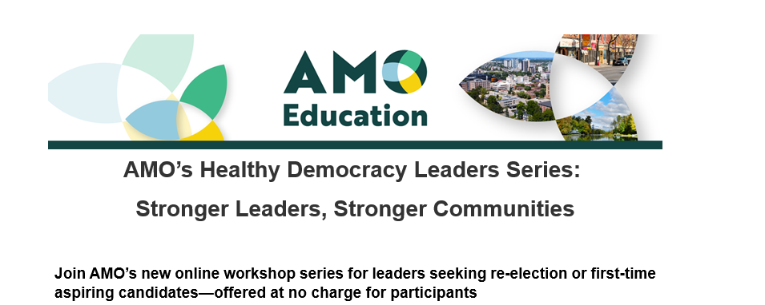

As Ontario heads toward the 2026 municipal elections, elected officials and aspiring candidates are being tested like never before. From navigating divisive politics and social media toxicity to maintaining personal well-being under constant public scrutiny, the demands of leadership can feel overwhelming.
Developed in partnership with Nominee, Stronger Leaders, Stronger Communities is designed to equip you with the tools, resilience, and confidence to meet these challenges head-on — and to rediscover the purpose that brought you to public service in the first place.
Through expert facilitation, guided peer-to-peer discussion, and practical takeaways, you’ll leave each session with fresh insight, renewed energy, and a stronger foundation for leadership.
This workshop is being offered for no charge:
- Session 1—November/December 2025: Finding Your Why – Leading with Purpose and Authenticity
- Session 2—January/February 2026: Praise Your Rivals – Managing Conflict and Building Effective Relationships
- Session 3—February/March 2026: What Matters Most – Prioritizing Mental Health and Wellbeing
- Session 4—March/April 2026: Building Your Movement – Turning Values into Action

What you’ll gain by attending these sessions:

- Clarity of Purpose: reconnect with your values and what drives you to serve
- Resilience in Conflict: handle tough situations with skill and confidence
- Personal Wellbeing: prevent burnout and create sustainable leadership practices
- Stronger Communication: inspire trust and mobilize authentic community support
- Practical Tools & Resources: customized workbooks, scripts, and templates you can use immediately
- Peer Connection: build relationships with others, also preparing to run in 2026

